Testing Flask API

- Start the Flask App
- Run it from Terminal
- Test Using Curl
-Open Command Prompt
-Run the command: curl http://127.0.0.1:5000/
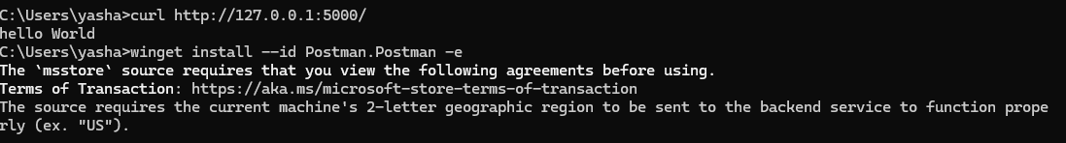
-Output:
- Test Using Postman
-Open Postman
-Click "New" > "HTTP Request"
-Set:
-Method: GET
-URL: http://127.0.0.1:5000/
-Click Send
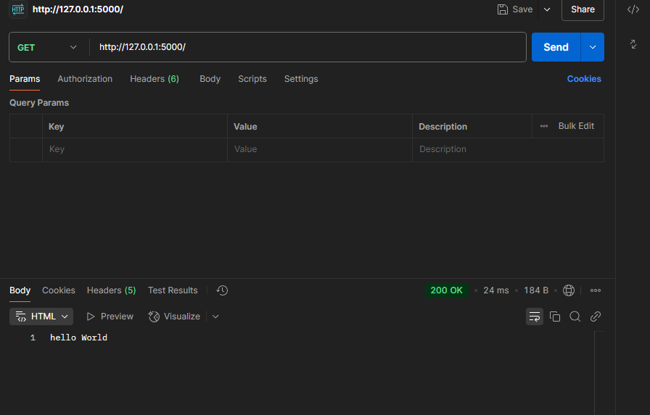
-Output:

